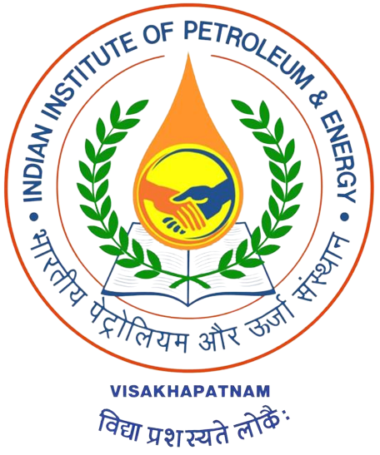

**INDIAN INSTITUTE OF PETROLEUM AND ENERGY**

**VISAKHAPATNAM**

**Proposal Form**

1. Application form for Seminar/ Symposia/ Conference/ Workshop/ Short-Term Course/ EDP

Please write any one :

2. Geographical Coverage : National/ International

3. Broad Subject Area :

4. In case of Joint Organization: Name and Address of the Second Organization

Institute :

Department :

Contact :

Website :

Pin code :

5. Number of Participants :

6. **Details of the Event**

* Title :
* Date :
* Duration :
* Address of the Venue :

7. Coordinator (s) :

8. Co-cordinator (s) :

9. **Funding Source Summary** **(in Rupees)**

Institute Internal Contribution :

Funding Agency :

Expected Registration Fees :

Contd…2/-

::2::

10. Is Accommodation required for Participants (approx.) : 1. Institute Hostel

(In Institute Hostels/ Guest House) 2. Guest House

11. Is Institute Transportation facility required : Yes / No

12. Any food arrangements in Hostel/ Guest house : Yes / No

13. Event Expenditure Estimate (in Rupees) :

|  |  |
| --- | --- |
| Honorarium to Experts |  |
| Honorarium to Coordinators |  |
| TA/DA |  |
| Pre-conference printing (Announcements, abstracts, etc.) |  |
| Publication of Proceedings |  |
| Stationery |  |
| Secretarial Assistance |  |
| Local Hospitality (including item 10,11,12 above) |  |
| Misc. |  |
| **Grand Total** |  |

14. Brief statement of objectives of the event :

15. Technical Program (sessions details attached) :

16. Brief statement on the steps you plan to take up to implement the recommendations of the seminar/ symposia/ conference (if applicable)

* I/we understand that overheads @ 15% of total budget payable to IIPE.

**Signature of the Course / Workshop Coordinator with date**

**(Head of the Department)**

**Associate Dean (R&D)** **Dean (R&D)**

APPROVED / NOT APPROVED

**DIRECTOR**